Linked list

Lyan Khaled bakrman

232310045

Ways to maintain a list in memory

1. Arrays: store elements in contiguous memory locations, resulting in easily calculable addresses for the elements stored and this allows faster access to an element at a specific index.
2. Linked list: are less rigid in their storage structure and elements are usually not stored in contiguous locations, hence they need to be stored with additional tags giving a reference to the next element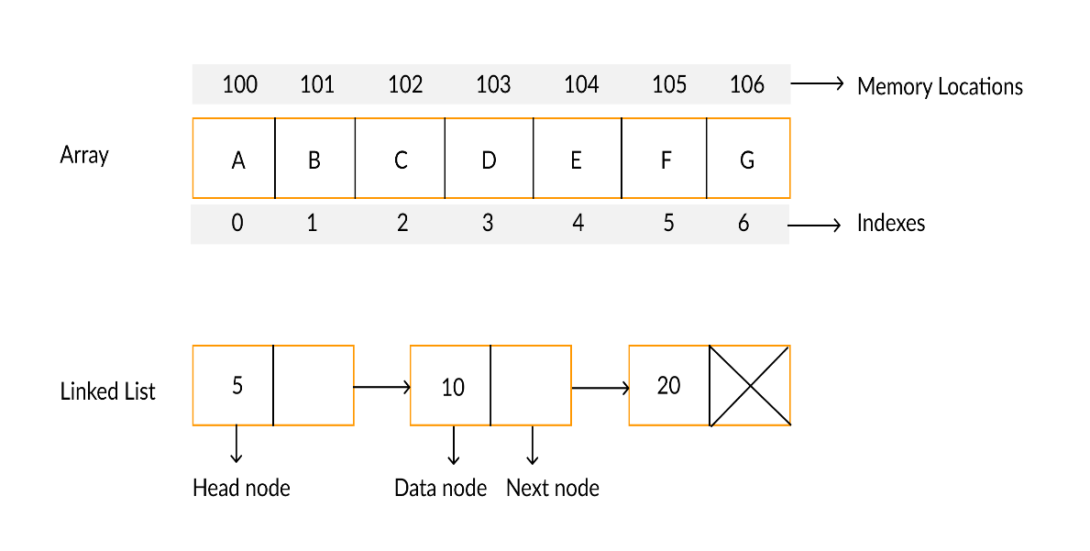

<https://i1.faceprep.in/Companies-1/difference-between-arrays-and-linked-list.png>

types of linked list

1. Single linked list: navigation is forward only.
2. Doubly linked list: navigation is forward and backward
3. Circular linked list: last element is linked to the first element

**Representation of Linked List**

* data items
* An address of another node



**Linked List Applications**

* Dynamic memory allocation
* Implemented in stack and queue
* In **undo** functionality of softwares
* Hash tables, Graphs

**Advantage:**

1. Dynamic data structure
2. Insertion and deletion of nodes is easy
3. No/low memory wase

**Disadvantage:**

1. Greater memory usage
2. No random access of element
3. Accessing /searching element is more time consuming

<https://youtu.be/N6dOwBde7-M?si=W9upPRsIdBEA6AFv>

<https://youtu.be/R9PTBwOzceo?si=yfXS5LB7KmdFyyJ1>

[Linked List vs Array - GeeksforGeeks](https://www.geeksforgeeks.org/linked-list-vs-array/)

[Linked List Data Structure (programiz.com)](https://www.programiz.com/dsa/linked-list)